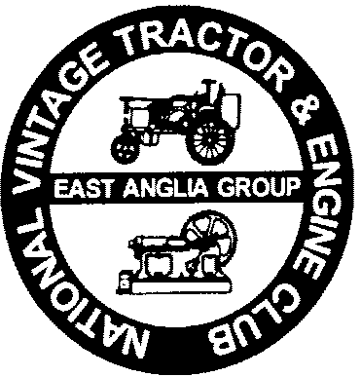
Sunday 29th March 2026
East Anglia Group
National Vintage Tractor & Engine Club
Charity Sponsored Road Run

In aid of the MAGPAS Air Ambulance

This year’s event will run from a new venue at Shouldham near Downham Market. This will be at a farm with kind permission from Mr Hipperson & son Melrose Farm, Shouldham, Norfolk, PE33 0DB.

Our road run will be held on Sunday 29th March 2026. On leaving the village of Shouldham we will head through approximately 30 miles of beautiful country lanes and villages stopping of at Narborough Community Centre, Chalk Lane, Narborough, PE32 1SR. Booking is recommended to avoid disappointment and delays so please book by ticking box below, payment to be made on the day to the village hall. We should arrive about 12.30pm - 100pm. After we have all enjoyed our lunch, we will head off again and we aim to arrive back to Shouldham at approximately 4.00pm to 4.30pm.

We plan to meet at 10.00am, set off at 10.30am, with the day drawing to a close around 5.00pm.

All tractors must be entered on the official paperwork and sponsored to a minimum level of £10.00.
Supreme Windows Ltd is sponsoring a trophy that will be awarded to the driver of the tractor gaining the most sponsorship.

To assist our planning please complete and return the form below as soon as possible to:
Mr David Askew, Hunters Lodge, 70 Smeeth Road, St Johns Fen End, Wisbech, Cambs, PE14 8JF


NVTEC East Anglia Group Charity Sponsored Road Run Sunday 29th March 2026
Supporting the MAGPAS Air Ambulance
The minimum level of sponsorship for entry is £10.00 per tractor.
I declare that during the whole period of the event my Entry will be covered by a Public Liability Policy including Rally use having a limit of indemnity of not less than £2,000,000 any one incident. I further declare that my vehicle is covered by insurance as required by the Road Traffic Act which is valid for the whole event as it takes place on roads as defined in that Act. I confirm that the driver/s of any vehicle entered holds and is not disqualified from holding a licence to drive a vehicle of the appropriate class.

Signed………………………………… My age is……………………… (if applicable state "Over 18 years")

Name (Please Print)…………………………………………….. Date………….…………
I would like to book a Full English Breakfast please tick below:

Yes No
Do you require camping /caravanning facilities? YES or NO
(delete as applicable)
Address..……………………………………………………………………………………………………….
Do you require camping /caravanning facilities? YES or NO
(delete as applicable)
Do you require camping /caravanning facilities? YES or NO
(delete as applicable)
Do you require camping /caravanning facilities? YES or NO
(delete as applicable)

…………………………………………………………………….……Post Code…………………………..

Telephone No……………………………………….
Tractor Make ………………………………….Year …………………….Model…………………………….

Registration Number………………………………………………….

Following NVTEC rules and advice from a National Safety Officer the following safety points will be strictly enforced
- Only one person (the Driver) is allowed on a tractor even if there is more than one seat

- Carrying of passengers on trailers of any type will not be permitted
Email address……………….………………………………………….
2026 Charity Road Run at
Mr Hipperson & Son, Melrose Farm, Shouldham, PE33 0DB

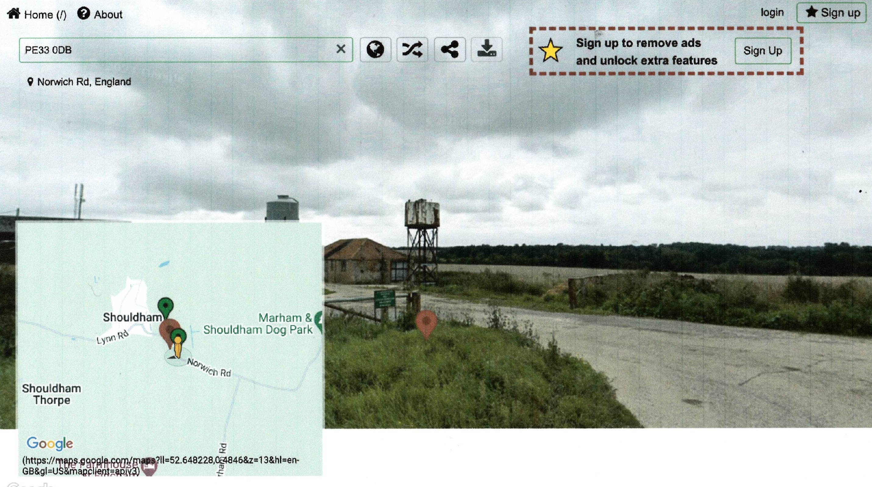

Gordon Carson 01945 880091 / 07860 658767 or David Askew 01945 430481
East Anglia Group
National Vintage Tractor & Engine Club
Spring Vintage Tractor Road Run

In aid of the East Anglian Air Ambulance
Sunday 29th March 2026

Name………………………… Tractor Registration number……………………
Sponsors Name | Amount Sponsored | Date Collected | Amount  Collected
 | £ |  | £
 | £ |  | £
 | £ |  | £
 | £ |  | £
 | £ |  | £
 | £ |  | £
 | £ |  | £
 | £ |  | £
 | £ |  | £
 | £ |  | £
 | £ |  | £
 | £ |  | £
 | £ |  | £
 | £ |  | £
 | £ |  | £
 | £ |  | £
 | £ |  | £
 | £ |  | £
 | £ |  | £
 | £ |  | £
 | £ |  | £
 | £ |  | £
 | £ |  | £
 | £ |  | £
Totals for this form | £ |  | £
It is the responsibility of person named above as the Entrant to collect and submit all sponsorship monies (minimum of £10.00 per entry). These should be submitted, along with this form, when booking in Walpole Highway on Sunday 29th March 2026.

If you have any queries relating to this form or event, contact
David Askew on 01945 430481or Gordon Carson on 01945 880091
Please photocopy this form if you require more.

